ØØ Explanation :
Let the 8 bit number be in the A register. We have to mask the lower nibble, i.e. we have to separate the lower nibble. In the result only MSB number should remain.
For example :
e.g. : A = 5B H. | 0101 | 1011
Logically AND with F0 H | 1111 | 0000
 | 0101 | 0000 | = 50 H
Result = 50 H, B is masked
Store the result.
ØØ Algorithm :
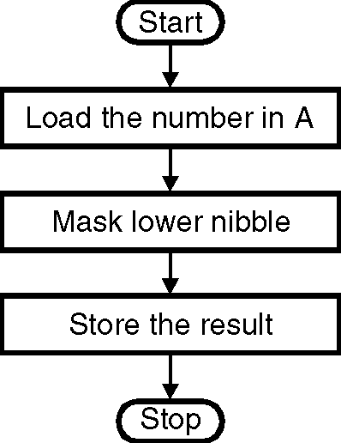
Step I : Load the number in A.
Step II : Mask lower nibble i.e. ANI 0F0 H.
Step III : Store result.
Step IV : Stop.
ØØ Flowchart : Refer flowchart 11.
➢➢ Program :
Instruction Comments
ANI 0F0 H ; Logically AND the number
MOV B, A ; Store the result.
HLT ; Terminate the execution Flowchart 11

